**Items from yesterday (reported by Adam & James):**

1. Modal Dialog scroll position stays in position you last left it. (JIRA [ETF-58](https://devtechnology.jira.com/browse/ETF-58))
2. Details data is not fully utilizing the full width of the dialog screen (especially on mobile). (JIRA [ETF-59](https://devtechnology.jira.com/browse/ETF-59)) - Backlog
3. Date formats should be changed to US format (mm/dd/yyyy). (JIRA [ETF-60](https://devtechnology.jira.com/browse/ETF-60))
4. Clicking on 'Drug Recall Information Center' should have the same effect as the 'Clear' button and take use to main screen. (JIRA [ETF-61](https://devtechnology.jira.com/browse/ETF-61))
5. Add Report Number on the search results list as this is a unique identifier of similar results in list. (JIRA [ETF-62](https://devtechnology.jira.com/browse/ETF-62))
6. Allow user to tap/click the drug image to get a close-up view of it (hard to see, especially on mobile). (JIRA [ETF-64](https://devtechnology.jira.com/browse/ETF-64)) - Backlog

**Added today (reported by Becky & Jackie):**

1. Search text box retains text from previous search after an advanced search is performed (JIRA [ETF-65](https://devtechnology.jira.com/browse/ETF-65))

* Perform search with “advil” on the homepage. Press search.
* Advil search returns 1 item.
* Click on advanced search & perform search on “blood” with all, ongoing, all options. Press search.
* Blood advanced search returns 5 items but the search text box still displays “advil”

1. Advanced search (JIRA [ETF-66](https://devtechnology.jira.com/browse/ETF-66))
   * close button should be after the search button
   * alignment of the search field boxes

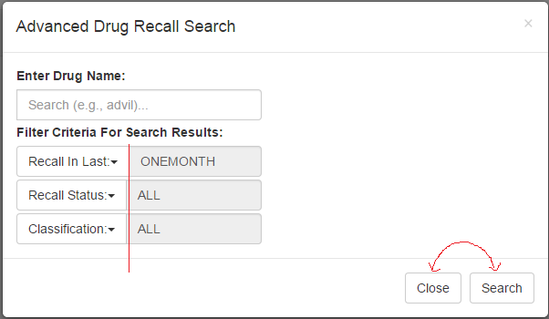

1. In advanced search, the dropdowns for each select field drop out of the dialog box view so users have to scroll to get to the bottom of the list. Can the dialog box be taller? (JIRA [ETF-67](https://devtechnology.jira.com/browse/ETF-67))

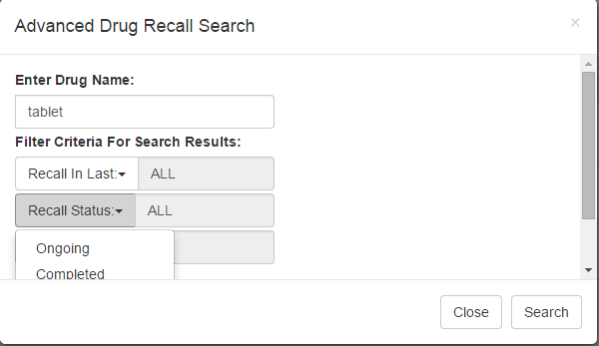

1. Results greater than 100, the result bar states “Results 259 of 100” rather than “Results 100 of 259”. (JIRA [ETF-68](https://devtechnology.jira.com/browse/ETF-68))
2. The “short product name”—in the meeting we said truncate at the first comma; in the wireframe it says truncate at first comma or first 50 chars. It is not truncating at first 50—should it? Acetazolamide is an example of 95 chars in product name. (JIRA [ETF-69](https://devtechnology.jira.com/browse/ETF-69)) - Closed
3. Section 508: Landing page—Dev logo has no ALT tag (JIRA [ETF-47](https://devtechnology.jira.com/browse/ETF-47))
4. Section 508: Adv Search: orphan form labels, the dropdowns are missing Form Control (JIRA [ETF-49](https://devtechnology.jira.com/browse/ETF-49))
5. Turn off exact search for keywords (JIRA [ETF-71](https://devtechnology.jira.com/browse/ETF-71))
6. Remove copyright statement (JIRA [ETF-70](https://devtechnology.jira.com/browse/ETF-70))
7. Move mobile nav bar to left from right (JIRA [ETF-69](https://devtechnology.jira.com/browse/ETF-69)) -Backlog
8. Pagination (JIRA [ETF-69](https://devtechnology.jira.com/browse/ETF-69)) -Backlog
9. Section 508: Detail page-The ALT tag on the drug image might not be optimal per WAVE (JIRA [ETF-69](https://devtechnology.jira.com/browse/ETF-69))
10. Mobile: On landing page, search bar is default. When I click the three bars to hide the search bar, on first click it does not hide it (when first on landing page)—on second click it does. (JIRA [ETF-76](https://devtechnology.jira.com/browse/ETF-76))
11. Classification legend (JIRA [ETF-63](https://devtechnology.jira.com/browse/ETF-63)) –Backlog
12. Re-label classifications to use roman numerals (i.e. Class II instead of Class 2) (JIRA [ETF-77](https://devtechnology.jira.com/browse/ETF-77))

**FYI & perhaps discussion items:**

1. Products referenced field—how often does it contain data? If less than 50% maybe drop that field from the details page as it is not useful and might be misleading info.
2. The image loaded very, very slowly for me on my laptop; phone was a little faster. Ciprofloxacin is an example.